🔍 1️⃣ Check Spark UI for Bottlenecks
Head to Spark UI → Stages/Tasks and look for:
• Skewed tasks → few tasks taking much longer.
• Large shuffle read/write → heavy joins or groupBy.
• High GC time → memory pressure.
• Spill to disk → insufficient executor memory.
✅ Fix: Repartition or broadcast small datasets, handle skew using salting or skew hints.
⸻
📊 2️⃣ Analyze Data Volume or Skew Changes
• Compare data size trends over recent runs.
• Check partition columns — skew often worsens with bad partitioning.
✅ Fix: Rebalance partitions, use dynamic allocation, or update partition keys.
⸻
⚙️ 3️⃣ Review Cluster Configuration
Check:
• Cluster type: Job vs High Concurrency
• Worker count, CPU, and RAM
• Autoscaling enabled?
✅ Fix: Scale workers, upgrade instance type, or enable autoscaling.
⸻
🧩 4️⃣ Inspect Code or Library Changes
• Any new joins, transformations, or version upgrades?
• Did someone tweak logic or Delta libraries?
✅ Fix: Profile and isolate the new slow stage.
⸻
🧠 5️⃣ Optimize Joins & Shuffles
• Use broadcast joins for small tables.
• Tune spark.sql.shuffle.partitions.
• Cache reused DataFrames.
spark.conf.set("spark.sql.shuffle.partitions", "400")
result = large_df.join(broadcast(small_df), "id")
⸻
💾 6️⃣ Review Storage & File Formats
• Check ADLS/Blob for latency or throttling.
• Avoid JSON/CSV for heavy reads.
✅ Fix: Convert to Parquet or Delta for performance.
⸻
📈 7️⃣ Monitor Cluster Metrics
Use Ganglia / Databricks metrics:
• Track CPU, memory, I/O bottlenecks.
• Identify executor loss or disk I/O saturation.
⸻
⚡ 8️⃣ Delta Lake Optimizations
OPTIMIZE delta.`/path/to/table` ZORDER BY (join_key);
VACUUM delta.`/path/to/table` RETAIN 168 HOURS;
Compact small files and clean old snapshots.
⸻
💡 Best Practices
✅ Enable Adaptive Query Execution (AQE)
✅ Use Delta cache for frequently used data
✅ Monitor Spark History Server regularly
✅ Parameterize configs for each environment (ADF or job clusters)
⸻
🔥 Pro Tip:
A slow Spark job is rarely about one issue — it’s usually data + cluster + code together.
Debug smartly, not blindly. 🚀
hashtag#Databricks hashtag#ApacheSpark hashtag#BigData hashtag#ETL hashtag#DataEngineering hashtag#PerformanceTuning hashtag#DeltaLake hashtag#AzureDatabricks
Activate to view larger image,
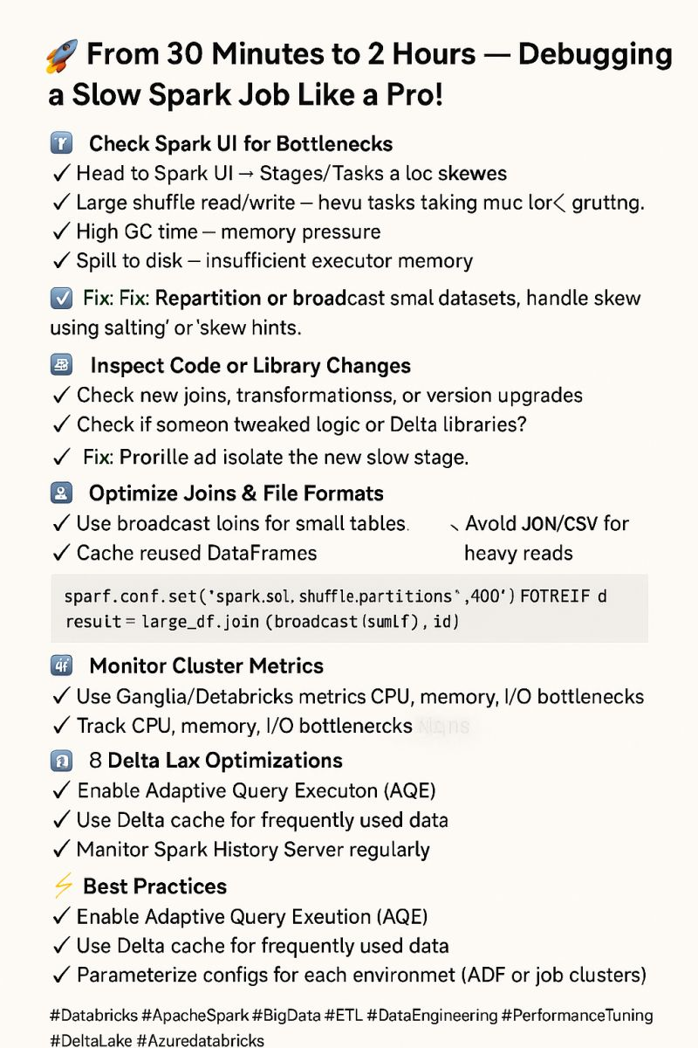
See content credentials

